**“Blog Website”**

**Using React and Firebase**

**Submitted By**

**Manthan Sharad Jadhav**

**Index:- Page No.**

1) Abstract 3

2) Project Purpose: 4

3) Project Objectives: 4

4) Key Features: 5

5) Programming Languages Use 6

6) Software Use 7

7) System Design 8

8) Data flow Diagram 8

9) Use Case Diagram 9

10) Implementation 10 - 12

11) Conclusion 13

**Abstract**

The React and Firebase Blog Website represents a contemporary web-based platform designed to facilitate the creation and discovery of blog content. Leveraging the robust capabilities of React for building an interactive user interface and Firebase for seamless user authentication, real-time data storage, and web hosting, this project presents an accessible and user-centric solution for bloggers and readers alike. By providing a user-friendly environment, complete with features like user authentication, dynamic blog post creation and management, responsive design, and Firebase's real-time synchronization, the website empowers writers to effortlessly share their thoughts while granting readers the opportunity to explore a diverse range of engaging content. With a commitment to a seamless user experience and the convenience of web accessibility, the React and Firebase Blog Website aspires to foster a thriving community of writers and readers, making it an ideal platform for creators of all backgrounds to express their ideas and for audiences to immerse themselves in captivating stories and insights.

This project brings together a powerful stack of technologies, including React, Firebase, React Router, CSS, and JavaScript, to create an intuitive and engaging web experience. Through the combination of these technologies and an emphasis on real-time data synchronization, the React and Firebase Blog Website exemplifies modern web development principles, ensuring that users can effortlessly navigate, interact with, and contribute to a dynamic online community.

**Project Purpose:**

This project's main goal is to make it super easy for people to write and share their thoughts on the internet. We want to give anyone the power to create their own blog posts without needing to be a tech expert. Whether you're a seasoned writer or just want to share your ideas, our website is here to help. You can sign up, write your posts And the best part is, you don't need any special software – just an internet connection. So, if you have something to say or love reading what others have to share, this website is all about making that process simple and fun for everyone.

In simple terms, our project is like an online space where people can write and share stories, ideas, and experiences. We use technology to make it all work smoothly, but you don't need to be a tech whiz to use it. Whether you're passionate about a topic or just want to see what others are talking about, our website is here to help you connect with writers and readers from all around the world. So, if you have a story to tell or enjoy reading what others write, join us on this adventure of words and ideas!

**Project Objectives:**

**1. User-Friendly Blogging:**

Create a user-friendly platform that allows both experienced writers and newcomers to easily write and share blog posts online.

**2. User Authentication:**

Implement robust user authentication to ensure secure access and content management, while also allowing visitors to read posts without requiring an account.

**3. Seamless Data Management:**

Utilize Firebase Firestore to seamlessly manage blog post data, user profiles, and other essential information, ensuring real-time updates and data synchronization.

**4. Responsive Design:**

Develop a responsive and visually appealing user interface that adapts to various devices and screen sizes, offering an excellent user experience across platforms.

**Key Features:**

**1. User Authentication:**

The website offers secure user registration and login functionality, ensuring that bloggers have control over their posts, and readers can personalize their experience.

**2. Blog Posts:**

Users can effortlessly create and delete blog posts, complete with titles, content

**3. Homepage:**

The homepage serves as a dynamic gateway to the latest blog posts, pulling data in real-time from the Firebase Fire-store database. Visitors can seamlessly explore content without authentication.

**4. Responsive Design:**

The website's responsive design ensures a consistent and enjoyable experience across devices and screen sizes, catering to both mobile and desktop users.

**5. Firebase Integration:**

Firebase plays a pivotal role in providing real-time data storage and synchronization, guaranteeing that blog posts and user data remain up-to-date across all devices.

**6. Deployment:**

The project is hosted on Firebase Hosting, extending its reach to users worldwide through the convenience of web access.

**Programming Languages:**

**JavaScript:-**

JavaScript is the primary programming language for developing the front-end of your React-based website. It's essential for creating interactive user interfaces and managing client-side functionality.

**HTML/CSS:-**

HTML (Hypertext Markup Language) and CSS (Cascading Style Sheets) are fundamental for structuring web pages and styling the website's user interface. They work in conjunction with JavaScript to create the web experience.

**Systems:**

**Web Browsers:**

The project is designed to be accessible via modern web browsers such as Google Chrome, Mozilla Firefox, Microsoft Edge, Safari, etc., ensuring cross-browser compatibility.

**Hardware:**

**Client Devices:**

The website is accessible on a wide range of client devices, including desktop computers, laptops, tablets, and smartphones. The hardware requirements are minimal, as modern web applications are designed to be lightweight and responsive.

**Software Use:**

**1. React:**

A JavaScript library used for building the user interface and managing the application's front-end.

**2. Firebase:**

A cloud-based platform from Google, providing the following services for your project:

**3. Firebase Authentication:**

Handles user authentication and authorization.

**4. Firebase Firestore:**

A NoSQL database used for storing and retrieving blog posts, user profiles, and other data.

**5. Firebase Hosting:**

Used for deploying and hosting the web application on the internet.

**6. React Router:**

A library for handling client-side routing within the React application, enabling navigation between different pages.

**7. Text Editor/IDE:**

A code editor or integrated development environment (IDE) of your choice for writing and managing your project's source code. Popular options include Visual Studio Code, Sublime Text, and JetBrains WebStorm.

**8. Git and Version Control:**

Version control system like Git for tracking changes to the project's codebase and collaborating with others, along with a platform like GitHub or GitLab for remote repository hosting.

**9. Node.js and npm:**

Node.js is used for running JavaScript on the server side, and npm (Node Package Manager) is used for managing project dependencies and running scripts.

**System Design**

Home

Login

**User**

Signup

Create Post

**Fig. System Design**

With the help of this module, user can perform the following Tasks/Actions. User can login or signup for this application, then user can create Post. User can see the posted data at home page. User can also delete the posted post

**Data flow Diagram**

**User**

**Login**

**Signup**

**Create Post**

**See Post At Home Page**

User first login to the project using email ID and password or by using goggle account. If the user doesn’t have account then it create account. Then User can create post and submit. User can see submitted post at Home Page. User can also see submitted post Without login.

**Use Case Diagram**



**Implementation**

**1. Login Page**

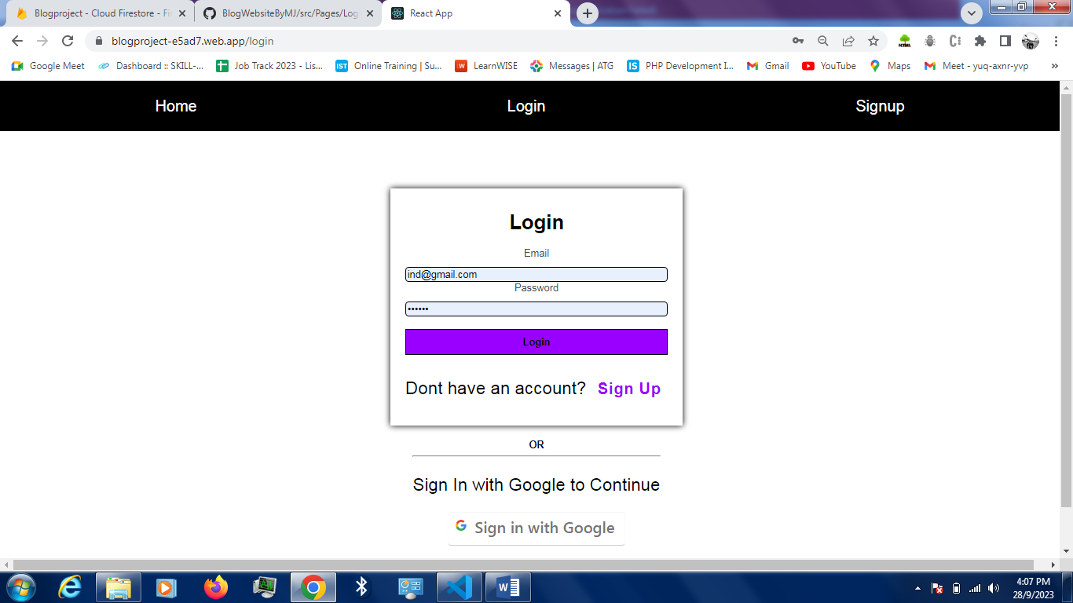

**2. Signup Page**

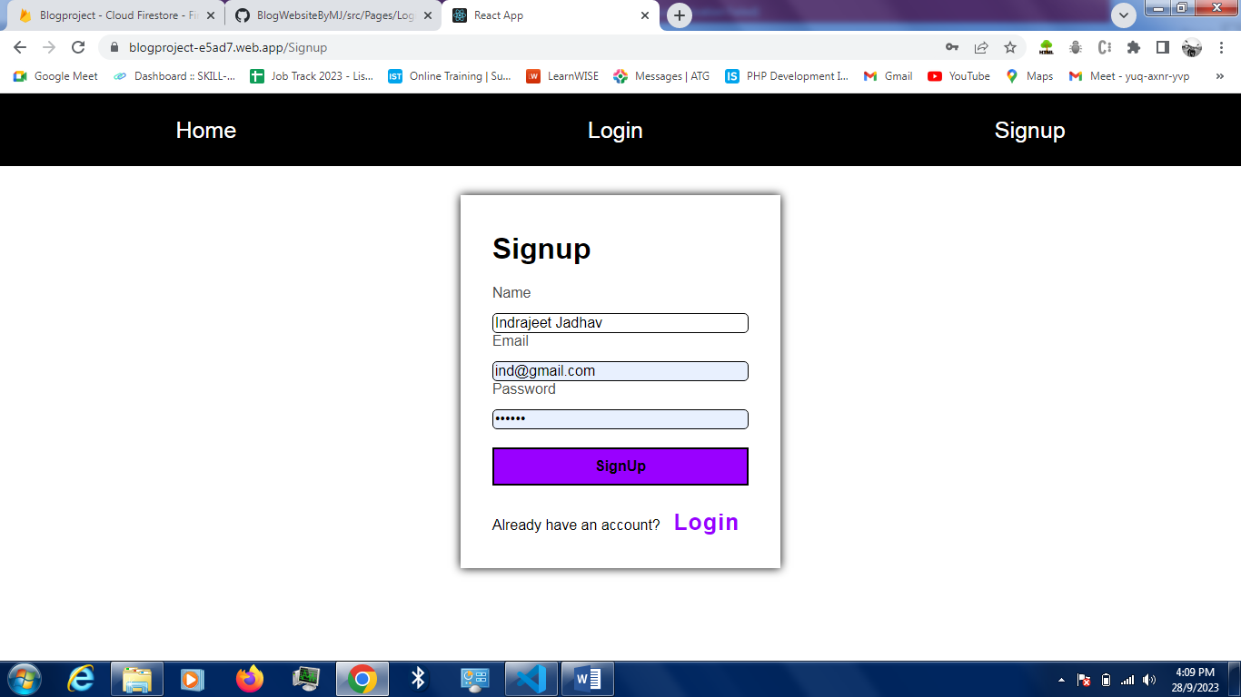

**3. Home Page Before Login**

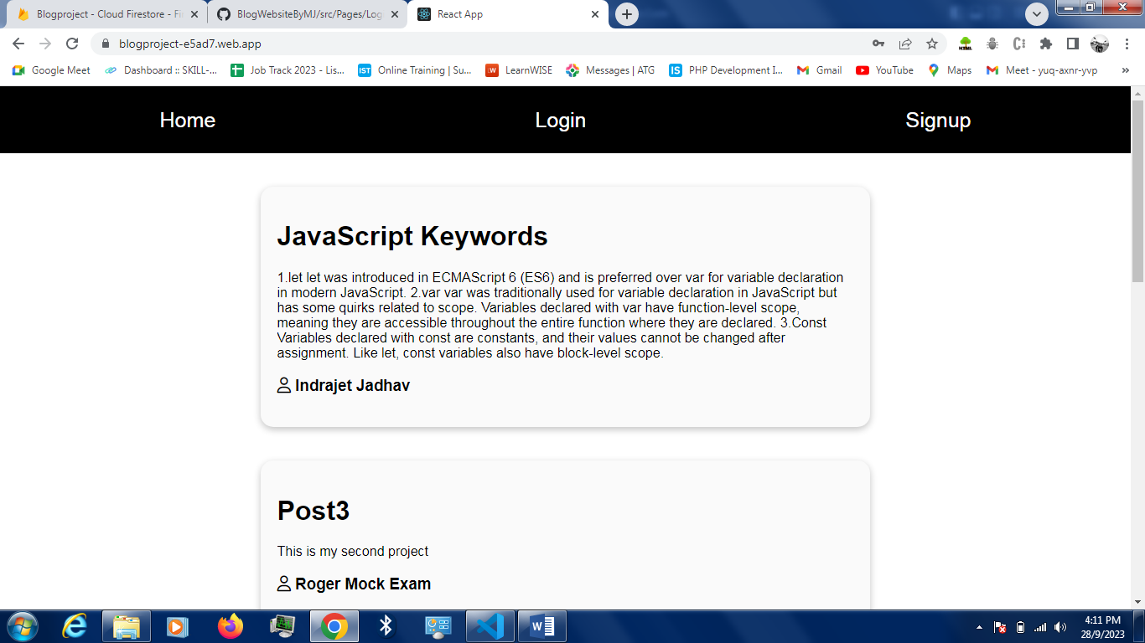

**4. Home Page After Login**

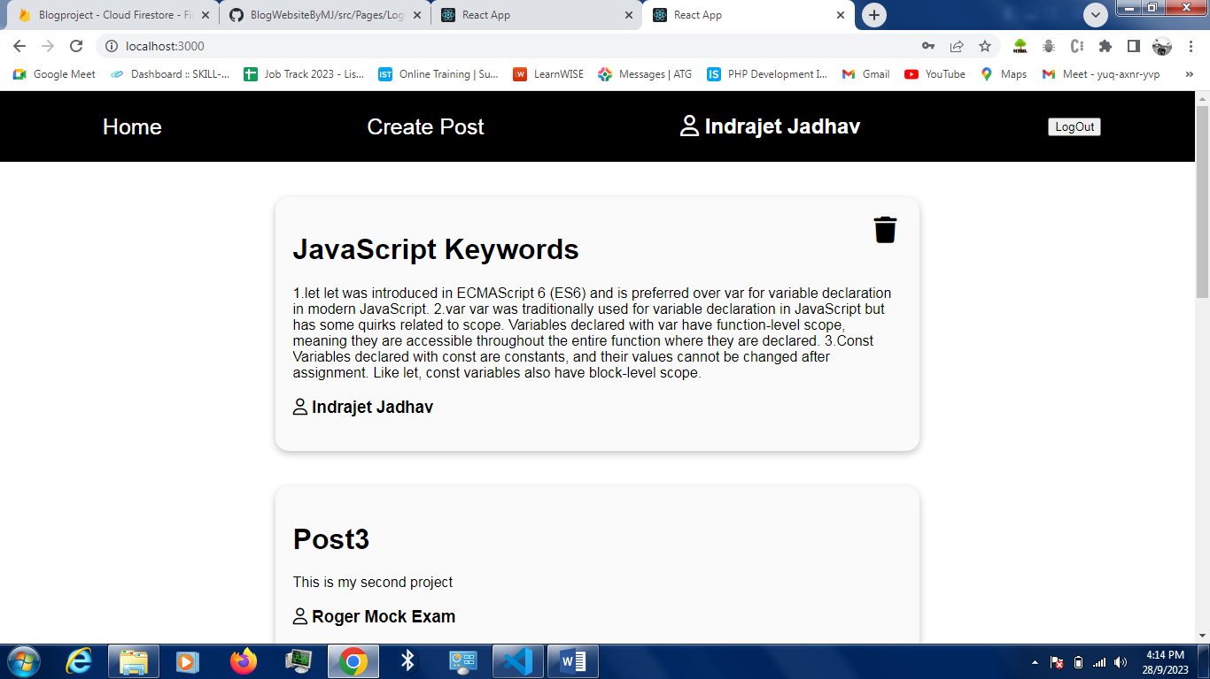

**5.Create Post Page**

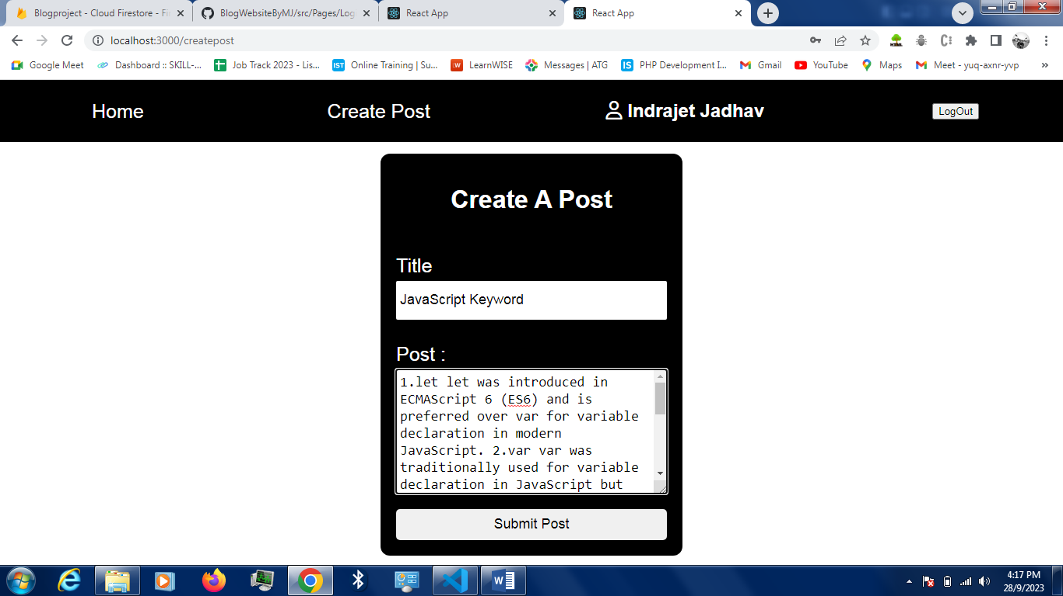

**Firebase Database**

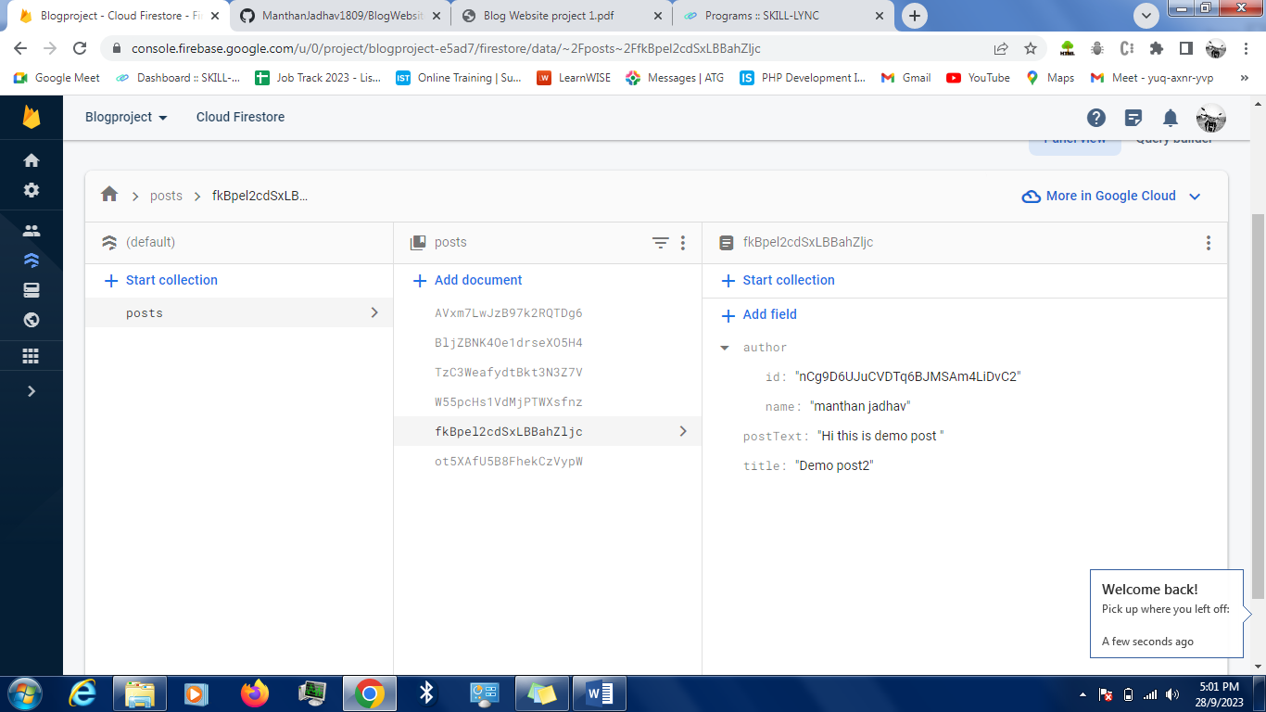

**Conclusion**

In conclusion, this project has successfully created a user-friendly and accessible platform for people to share their thoughts and stories with the world. By combining the power of React and Firebase, we've made it easy for both new and experienced writers to create and manage their blog posts, while also providing readers with a seamless and enjoyable experience. This project is not just about technology; it's about fostering a community of writers and readers who can connect, learn, and share their passions. We hope that this website will continue to inspire and empower individuals to express themselves and discover new perspectives in the ever-evolving world of online content.